CS 4121 **Due: 3:30pm, 11/04/19**

**GENI Lab 7, Part I: Dijkstra’s Algorithm** **(32 points)**

Step 2.1 (from the instructions document):

Working table:

|  |  |  |  |  |  |  |  |  |  |
| --- | --- | --- | --- | --- | --- | --- | --- | --- | --- |
| **Iteration** | **Unvisited** | **Visited** | **Current** | **dijkstra** | **cerf** | **lovelace** | **hopper** | **baran** | **knuth** |
| 0 | dijkstra, cerf, lovelace, hopper, baran, knuth | - | - | 0 | ∞ | ∞ | ∞ | ∞ | ∞ |
| - | - | - | - | - | - |
| 1 | cerf, lovelace, hopper, baran, knuth | dijkstra | dijkstra | 0 | ∞ | 121.628 | ∞ | 189.618 | ∞ |
| - | - | dijkstra | - | dijkstra | - |
| 2 |  |  |  |  |  |  |  |  |  |
|  |  |  |  |  |  |
| 3 |  |  |  |  |  |  |  |  |  |
|  |  |  |  |  |  |
| 4 |  |  |  |  |  |  |  |  |  |
|  |  |  |  |  |  |
| 5 |  |  |  |  |  |  |  |  |  |
|  |  |  |  |  |  |
| 6 |  |  |  |  |  |  |  |  |  |
|  |  |  |  |  |  |

Screenshot of the terminal for the “dijkstra” node below. Make sure it includes all relevant “ping” commands and their outputs:

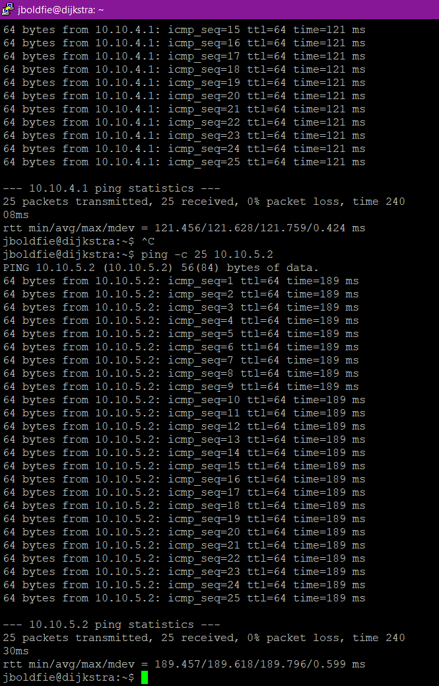

Link costs figure:

Update the following figure with links costs between “dijkstra” and “baran”; “dijkstra” and “lovelace”.

hopper

cerf

knuth

lovelace

121.628

189.618

baran

dijkstra

Step 2.2 (from the instructions document):

Working table:

|  |  |  |  |  |  |  |  |  |  |
| --- | --- | --- | --- | --- | --- | --- | --- | --- | --- |
| **Iteration** | **Unvisited** | **Visited** | **Current** | **dijkstra** | **cerf** | **lovelace** | **hopper** | **baran** | **knuth** |
| 0 | dijkstra, cerf, lovelace, hopper, baran, knuth | - | - | 0 | ∞ | ∞ | ∞ | ∞ | ∞ |
| - | - | - | - | - | - |
| 1 | cerf, lovelace, hopper, baran, knuth | dijkstra | dijkstra | 0 | ∞ | 121.628 | ∞ | 189.618 | ∞ |
| - | - | dijkstra | - | dijkstra | - |
| 2 | cerf, hopper, baran, knuth | dijkstra, lovelace | lovelace | 0 | ∞ | 121.628 | 230.236 | 189.618 | 192.229 |
| - | - | dijkstra | lovelace | dijkstra | lovelace |
| 3 |  |  |  |  |  |  |  |  |  |
|  |  |  |  |  |  |
| 4 |  |  |  |  |  |  |  |  |  |
|  |  |  |  |  |  |
| 5 |  |  |  |  |  |  |  |  |  |
|  |  |  |  |  |  |
| 6 |  |  |  |  |  |  |  |  |  |
|  |  |  |  |  |  |

Screenshot of the terminal for the your chosen node below. Make sure it includes all relevant “ping” commands and their outputs:

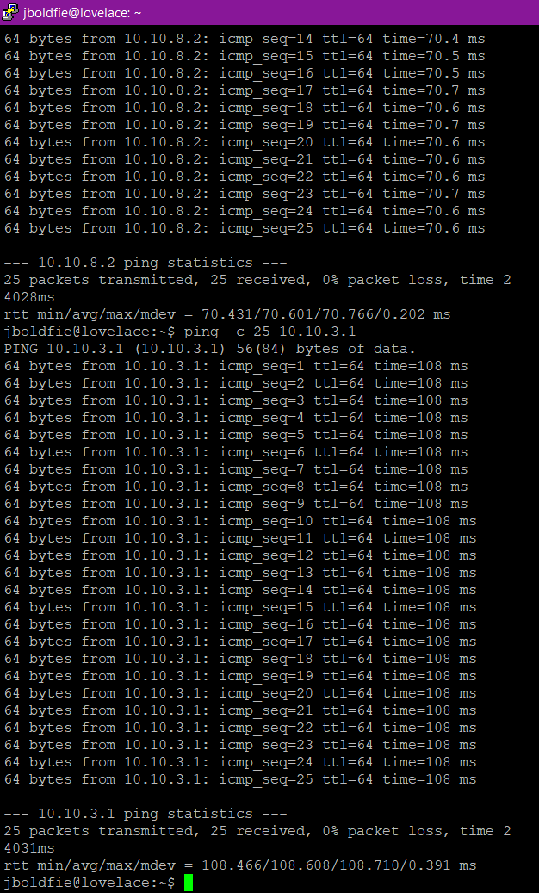

Link costs figure:

Update the following figure with new links costs that you’ve discovered.

hopper

cerf

108.608

knuth

70.601

lovelace



189.618

baran

dijkstra

Step 2.3 (from the instructions document):

Working table:

|  |  |  |  |  |  |  |  |  |  |
| --- | --- | --- | --- | --- | --- | --- | --- | --- | --- |
| **Iteration** | **Unvisited** | **Visited** | **Current** | **dijkstra** | **cerf** | **lovelace** | **hopper** | **baran** | **knuth** |
| 0 | dijkstra, cerf, lovelace, hopper, baran, knuth | - | - | 0 | ∞ | ∞ | ∞ | ∞ | ∞ |
| - | - | - | - | - | - |
| 1 | cerf, lovelace, hopper, baran, knuth | dijkstra | dijkstra | 0 | ∞ | 121.628 | ∞ | 189.618 | ∞ |
| - | - | dijkstra | - | dijkstra | - |
| 2 | cerf, hopper, baran, knuth | dijkstra, lovelace | lovelace | 0 | ∞ | 121.628 | 230.236 | 189.618 | 192.229 |
| - | - | dijkstra | lovelace | dijkstra | lovelace |
| 3 | cerf, hopper, knuth | dijkstra, lovelace, baran | baran | 0 | 311.987 | 121.628 | 230.236 | 189.618 | 192.229 |
| - | baran | dijkstra | lovelace | dijkstra | lovelace |
| 4 |  |  |  |  |  |  |  |  |  |
|  |  |  |  |  |  |
| 5 |  |  |  |  |  |  |  |  |  |
|  |  |  |  |  |  |
| 6 |  |  |  |  |  |  |  |  |  |
|  |  |  |  |  |  |

Screenshot of the terminal for the your chosen node below. Make sure it includes all relevant “ping” commands and their outputs:

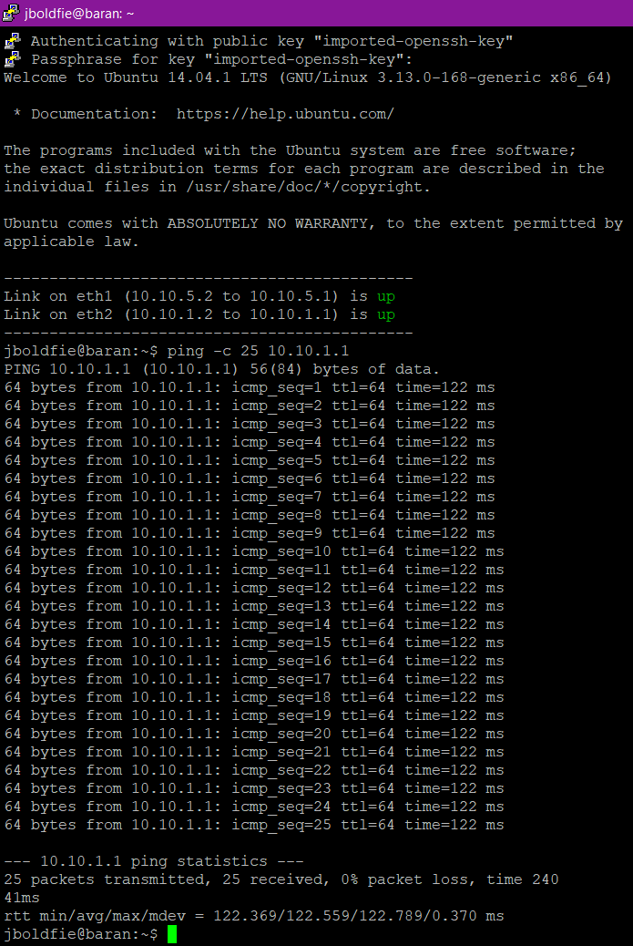

Link costs figure:

Update the following figure with new links costs that you’ve discovered.

hopper

cerf

122.369

108.608

knuth

70.601

lovelace



189.618

baran

dijkstra

Step 2.4 (from the instructions document):

Working table:

|  |  |  |  |  |  |  |  |  |  |
| --- | --- | --- | --- | --- | --- | --- | --- | --- | --- |
| **Iteration** | **Unvisited** | **Visited** | **Current** | **dijkstra** | **cerf** | **lovelace** | **hopper** | **baran** | **knuth** |
| 0 | dijkstra, cerf, lovelace, hopper, baran, knuth | - | - | 0 | ∞ | ∞ | ∞ | ∞ | ∞ |
| - | - | - | - | - | - |
| 1 | cerf, lovelace, hopper, baran, knuth | dijkstra | dijkstra | 0 | ∞ | 121.628 | ∞ | 189.618 | ∞ |
| - | - | dijkstra | - | dijkstra | - |
| 2 | cerf, hopper, baran, knuth | dijkstra, lovelace | lovelace | 0 | ∞ | 121.628 | 230.236 | 189.618 | 192.229 |
| - | - | dijkstra | lovelace | dijkstra | lovelace |
| 3 | cerf, hopper, knuth | dijkstra, lovelace, baran | baran | 0 | 311.987 | 121.628 | 230.236 | 189.618 | 192.229 |
| - | baran | dijkstra | lovelace | dijkstra | lovelace |
| 4 | cerf, hopper | dijkstra, lovelace, baran, knuth | knuth | 0 | 261.798 | 121.628 | 230.236 | 189.618 | 192.229 |
| - | knuth | dijkstra | lovelace | dijsktra | lovelace |
| 5 |  |  |  | 0 |  |  |  |  |  |
| - |  |  |  |  |  |
| 6 |  |  |  | 0 |  |  |  |  |  |
| - |  |  |  |  |  |

Screenshot of the terminal for the your chosen node below. Make sure it includes all relevant “ping” commands and their outputs:

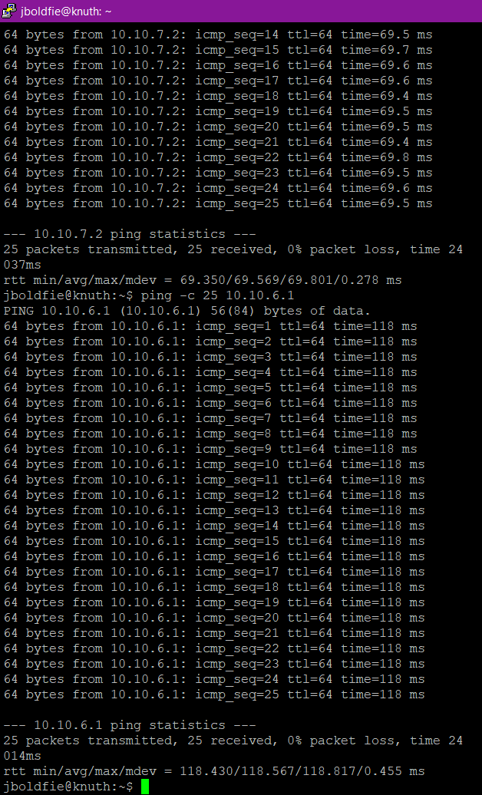

Link costs figure:

Update the following figure with new links costs that you’ve discovered.

hopper

cerf

118.567

69.569

122.369

108.608

knuth

70.601

lovelace



189.618

baran

dijkstra

Step 2.5 (from the instructions document):

Working table:

|  |  |  |  |  |  |  |  |  |  |
| --- | --- | --- | --- | --- | --- | --- | --- | --- | --- |
| **Iteration** | **Unvisited** | **Visited** | **Current** | **dijkstra** | **cerf** | **lovelace** | **hopper** | **baran** | **knuth** |
| 0 | dijkstra, cerf, lovelace, hopper, baran, knuth | - | - | 0 | ∞ | ∞ | ∞ | ∞ | ∞ |
| - | - | - | - | - | - |
| 1 | cerf, lovelace, hopper, baran, knuth | dijkstra | dijkstra | 0 | ∞ | 121.628 | ∞ | 189.618 | ∞ |
| - | - | dijkstra | - | dijkstra | - |
| 2 | cerf, hopper, baran, knuth | dijkstra, lovelace | lovelace | 0 | ∞ | 121.628 | 230.236 | 189.618 | 192.229 |
| - | - | dijkstra | lovelace | dijkstra | lovelace |
| 3 | cerf, hopper, knuth | dijkstra, lovelace, baran | baran | 0 | 311.987 | 121.628 | 230.236 | 189.618 | 192.229 |
| - | baran | dijkstra | lovelace | dijkstra | lovelace |
| 4 | cerf, hopper | dijkstra, lovelace, baran, knuth | knuth | 0 | 261.798 | 121.628 | 230.236 | 189.618 | 192.229 |
| - | knuth | dijkstra | lovelace | dijsktra | lovelace |
| 5 | cerf | dijsktra, lovelace, baran, knuth, hopper | hopper | 0 | 261.798 | 121.628 | 230.236 | 189.618 | 192.229 |
| - | knuth | dijkstra | lovelace | dijkstra | lovelace |
| 6 |  |  |  |  |  |  |  |  |  |
|  |  |  |  |  |  |

Screenshot of the terminal for the your chosen node below. Make sure it includes all relevant “ping” commands and their outputs:

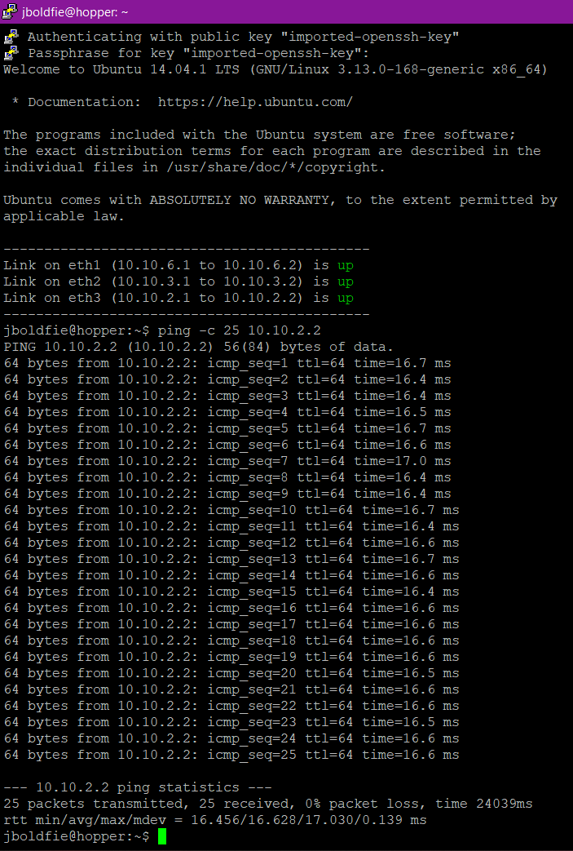

Link costs figure:

Update the following figure with new links costs that you’ve discovered.

16.628

hopper

cerf

118.567

69.569

122.369

108.608

knuth

70.601

lovelace



189.618

baran

dijkstra

Step 2.6 (from the instructions document):

Working table:

|  |  |  |  |  |  |  |  |  |  |
| --- | --- | --- | --- | --- | --- | --- | --- | --- | --- |
| **Iteration** | **Unvisited** | **Visited** | **Current** | **dijkstra** | **cerf** | **lovelace** | **hopper** | **baran** | **knuth** |
| 0 | dijkstra, cerf, lovelace, hopper, baran, knuth | - | - | 0 | ∞ | ∞ | ∞ | ∞ | ∞ |
| - | - | - | - | - | - |
| 1 | cerf, lovelace, hopper, baran, knuth | dijkstra | dijkstra | 0 | ∞ | 121.628 | ∞ | 189.618 | ∞ |
| - | - | dijkstra | - | dijkstra | - |
| 2 | cerf, hopper, baran, knuth | dijkstra, lovelace | lovelace | 0 | ∞ | 121.628 | 230.236 | 189.618 | 192.229 |
| - | - | dijkstra | lovelace | dijkstra | lovelace |
| 3 | cerf, hopper, knuth | dijkstra, lovelace, baran | baran | 0 | 311.987 | 121.628 | 230.236 | 189.618 | 192.229 |
| - | baran | dijkstra | lovelace | dijkstra | lovelace |
| 4 | cerf, hopper | dijkstra, lovelace, baran, knuth | knuth | 0 | 261.798 | 121.628 | 230.236 | 189.618 | 192.229 |
| - | knuth | dijkstra | lovelace | dijsktra | lovelace |
| 5 | cerf | dijsktra, lovelace, baran, knuth, hopper | hopper | 0 | 261.798 | 121.628 | 230.236 | 189.618 | 192.229 |
| - | knuth | dijkstra | lovelace | dijkstra | lovelace |
| 6 |  | dijkstra, lovelace, baran, knuth, hopper, cerf | cerf | 0 | 261.798 | 121.628 | 230.236 | 189.618 | 192.229 |
| - | knuth | dijkstra | lovelace | dijkstra | lovelace |

Screenshot of the terminal for the your chosen node below. Make sure it includes all relevant “ping” commands and their outputs:

***ALL NEIGHBORS VISITED!!***

***NO NEED FOR PING***

Link costs figure:

Update the following figure with new links costs that you’ve discovered.

16.628

hopper

cerf

118.567

69.569

122.369

108.608

knuth

70.601

lovelace



189.618

baran

dijkstra

Step 3 (from the instructions document):

Minimum-cost tree (mark links and network interfaces on your tree with red; gray otherwise):

